**+Responsive Web Design Projects - Build a Technical Documentation Page**

**User Story #1:** I can see a main element with a corresponding id="main-doc", which contains the page's main content (technical documentation).

**User Story #2+**

**User Story #3:** The first element within each .main-section should be a header element which contains text that describes the topic of that section.

**User Story #4:** Each section element with the class of main-section should also have an id that corresponds with the text of each header contained within it. Any spaces should be replaced with underscores (e.g. The section that contains the header "JavaScript and Java" should have a corresponding id="JavaScript_and_Java").

**User Story #5:** The .main-section elements should contain at least 10 p elements total (not each).

**User Story #6:** The .main-section elements should contain at least 5 code elements total (not each).

**User Story #7:** The .main-section elements should contain at least 5 li items total (not each).

**User Story #8:** I can see a nav element with a corresponding id="navbar".

**User Story #9:** The navbar element should contain one header element which contains text that describes the topic of the technical documentation.

**User Story #10:** Additionally, the navbar should contain link (a) elements with the class of nav-link. There should be one for every element with the class main-section.

**User Story #11:** The header element in the navbar must come before any link (a) elements in the navbar.

**User Story #12:** Each element with the class of nav-link should contain text that corresponds to the header text within each section (e.g. if you have a "Hello world" section/header, your navbar should have an element which contains the text "Hello world").

**User Story #13:** When I click on a navbar element, the page should navigate to the corresponding section of the main-doc element (e.g. If I click on a nav-link element that contains the text "Hello world", the page navigates to a section element that has that id and contains the corresponding header.

**User Story #14:** On regular sized devices (laptops, desktops), the element with id="navbar" should be shown on the left side of the screen and should always be visible to the user.

**User Story #15:** My Technical Documentation page should use at least one media query.

Note your output should be similar to this wireframe

<https://xd.adobe.com/view/84a6b908-e3b7-4ba2-91c9-f7288957d44a-d1f5/>

Documentation Page

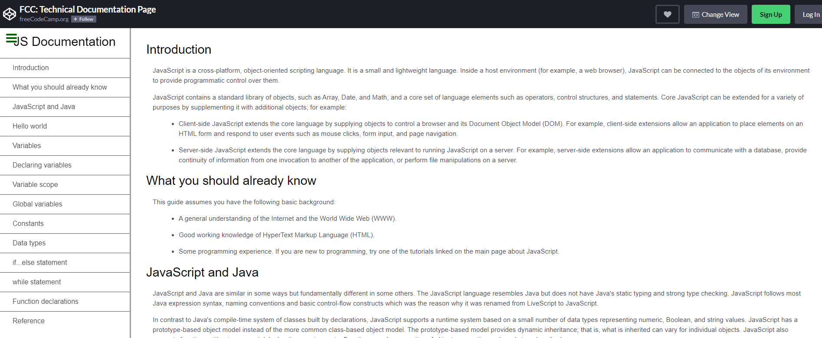

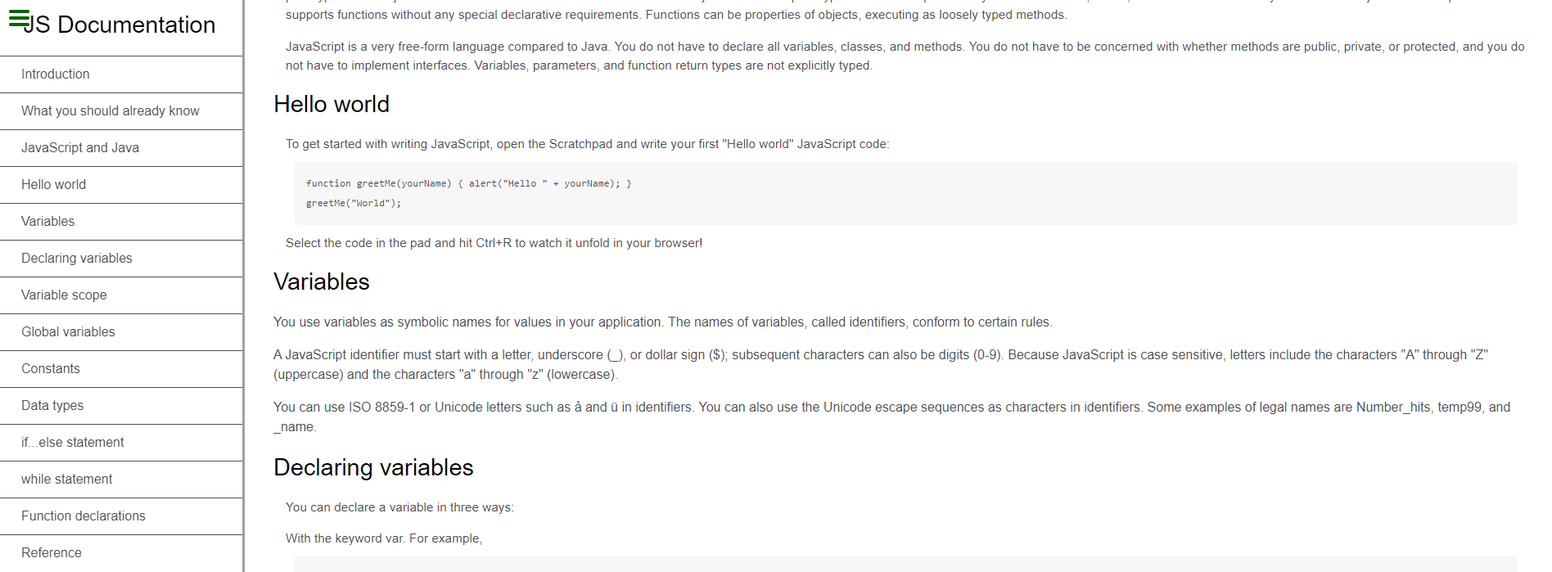

For Change View Button Click we should be able to get this output 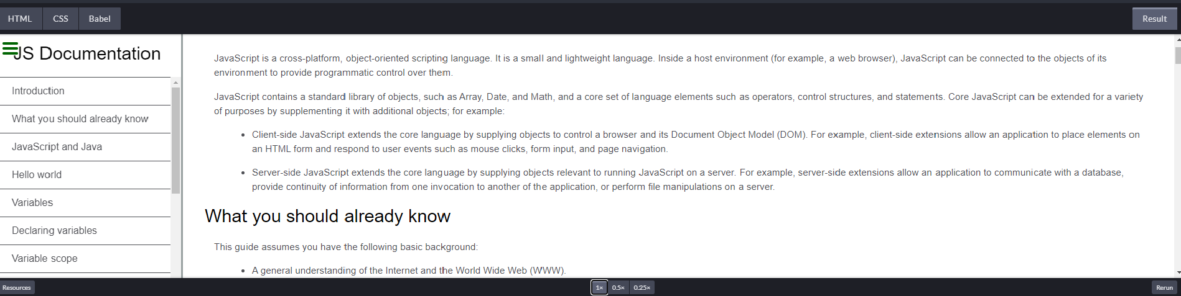



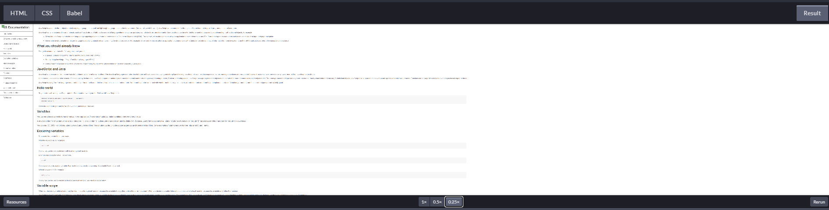



For these ….link them to any SignUp and Log In Page

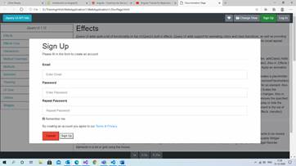

On this Sign Up pop up 3 fields are there Email,Password,Repeat Password for all these fields on button **Sign Up** validations has to be done with JS.

On Cancel button click all fields has to be clear and close pop up.

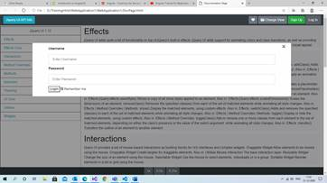

Validate Username and Password field with JS. And after that click on Login button it has to redirect to another page with JS.